PEACEFUL PROTESTS – THE SUFFRAGISTS
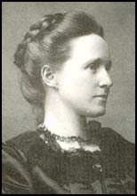
Millicent Fawcett
Founded the National Union of Women's Suffrage in 1897
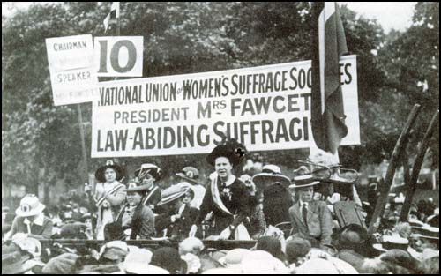
Millicent Fawcett believed in peaceful protest. She felt that if women were violent or caused trouble then men would say that women could not be trusted to have the right to vote

MRS FAWCETT SAYS:
“Women have responsible posts in society such as sitting on school boards - they should be allowed to vote”
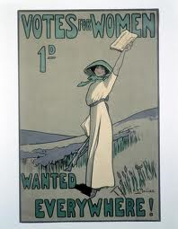
“We obey the laws set out by Parliament therefore we should have a say in who makes the laws by being allowed to vote”’
“We pay taxes just like me therefore we should be allowed to vote!”
“Wealthy women employ male gardeners and servants to help in the house – these men can vote but the woman cannot!”
“We can get results though peaceful and political ways”
“Spread our message through posters, newspaper articles, letters and speeches”
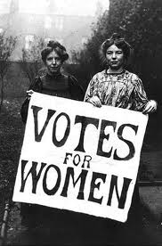
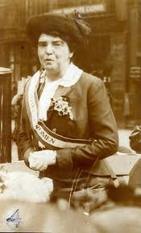
Posters used by the peaceful Suffragist campaigners to spread their message

The Suffragist women made posters and banners to spread their message
The Suffragist women wore sashes with their campaign messages on

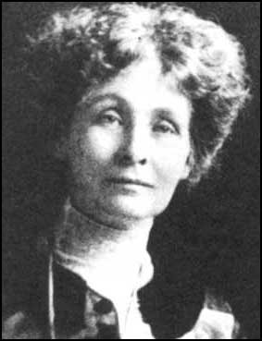
VIOLENT PROTESTS –THE SUFFRAGETTES
Emmeline Pankhurst founded the Women's Social and Political Union in 1903 with her daughters Christabel and Sylvia.
MRS PANKHURST SAYS:
“Mrs. Fawcett’s campaign for women was too slow and she achieved very few results – we need something more”
“Members of the Suffragettes are prepared to use violence to get what women the vote”
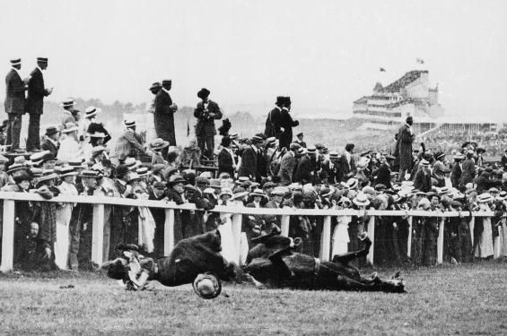
“My daughter Christabel was arrested in 1905 after standing up to two politicians, she shouted at them, asking them if they believed women should have the vote”
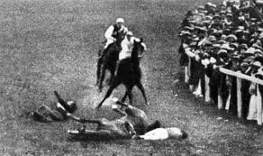
The most famous act associated with the Suffragettes was at the June 1913 Derby when Emily Davison threw herself under the King's horse, she was killed.

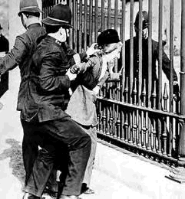
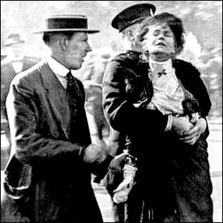

Women chained themselves to railings, even the ones outside Buckingham Palace to get attention for their campaign
Lots of women involved in the violent campaigns were arrested. In prison they continued their campaign and went on hunger strikes, this forced the government to pay attention to them

