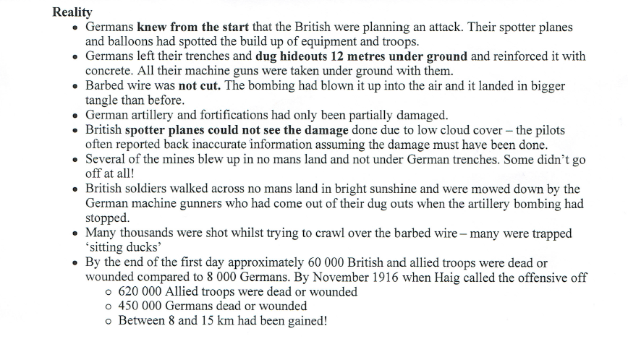

The Battle of the Somme – 1st July 1916 – November 1916

The Battle of the Somme – 1st July 1916 – November 1916