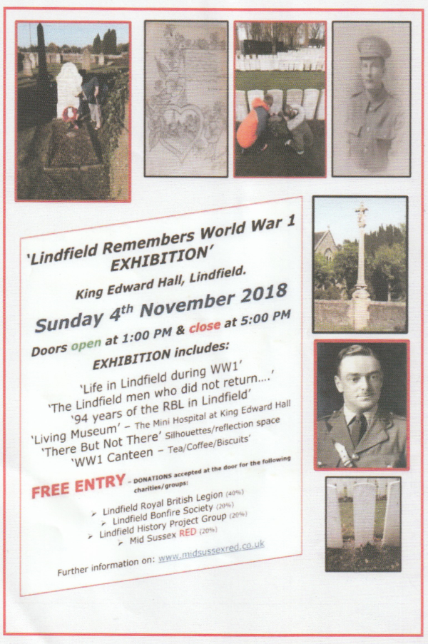

http://www.eastsussexww1.org.uk/events/

Family history talk - Researching First World War ancestors
Worthing Library - Thursday 8 November

Event information
A talk offering expert help and advice on researching your WW1 military ancestors, particularly for those who have already started their family history and want advice on going further.
Join one of our Enquiries Librarians for the morning at this event.
The talk includes a two-hour training session served up with coffee or tea and biscuits.

Event details
Venue: Worthing Library
Date: Thursday 8 November 2018
Time: 10.00am to 12 noon
Tickets: £5.00 (non-refundable) available from the library

Library phone number
01903 704809

November 1918: Burgess Hill’s last casualties
Burgess Hill Library - Thursday 8 November

Event information
An illustrated talk by Tim Stanton, Librarian.
To commemorate the 100th anniversary of the end of the First World War and using resources available from West Sussex Libraries and the internet, this talk will look at the lives and final days of some of the soldiers from Burgess Hill who died across the world in the final weeks of the conflict.
Tea and coffee will be available on arrival.

Event details
Venue: Burgess Hill Library
Date: Thursday 8 November 2018
Time: 7.00pm to 8.30pm
Tickets: £5.00 (non-refundable) available from the library

Library phone number
01444 255452

Exhibition at Marlipins Museum gives insight into Shoreham during the First World War
Marlipins Museum is offering the opportunity for visitors to get an insight into Shoreham’s role in the First World War with its new exhibition The First Great Silence.
Open until 11th November
Read more at:
https://www.worthingherald.co.uk/news/exhibition-at-marlipins-museum-gives-insight-into-shoreham-during-the-first-world-war-1-8639301
*********************************

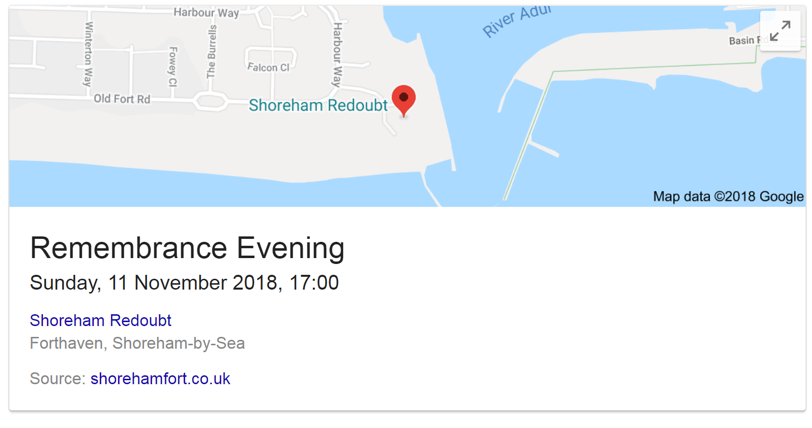

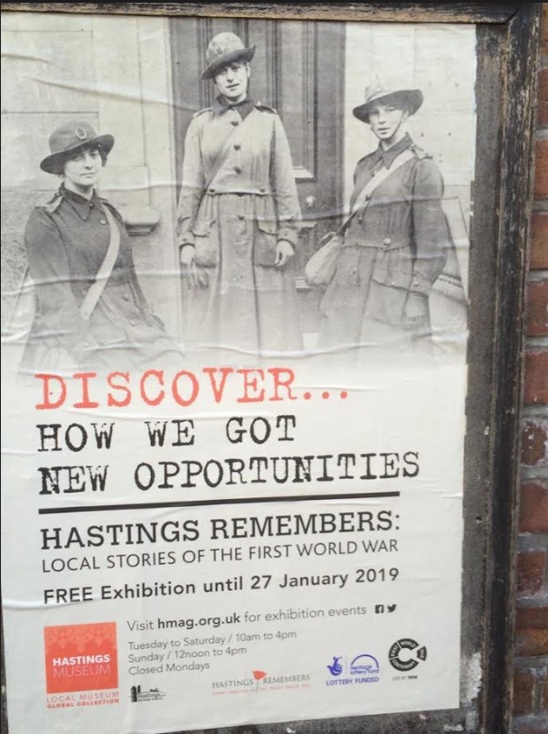

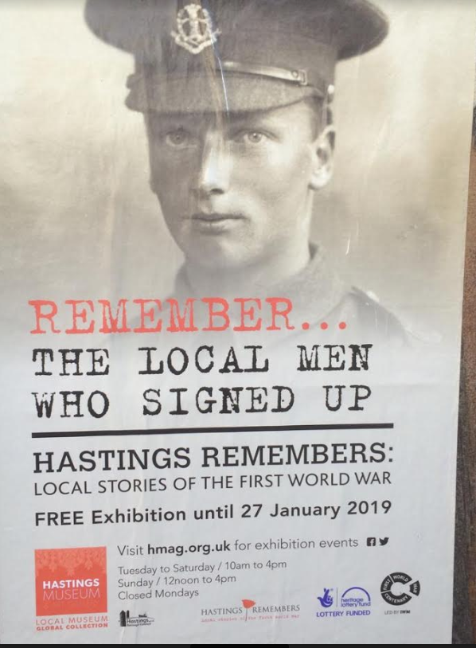
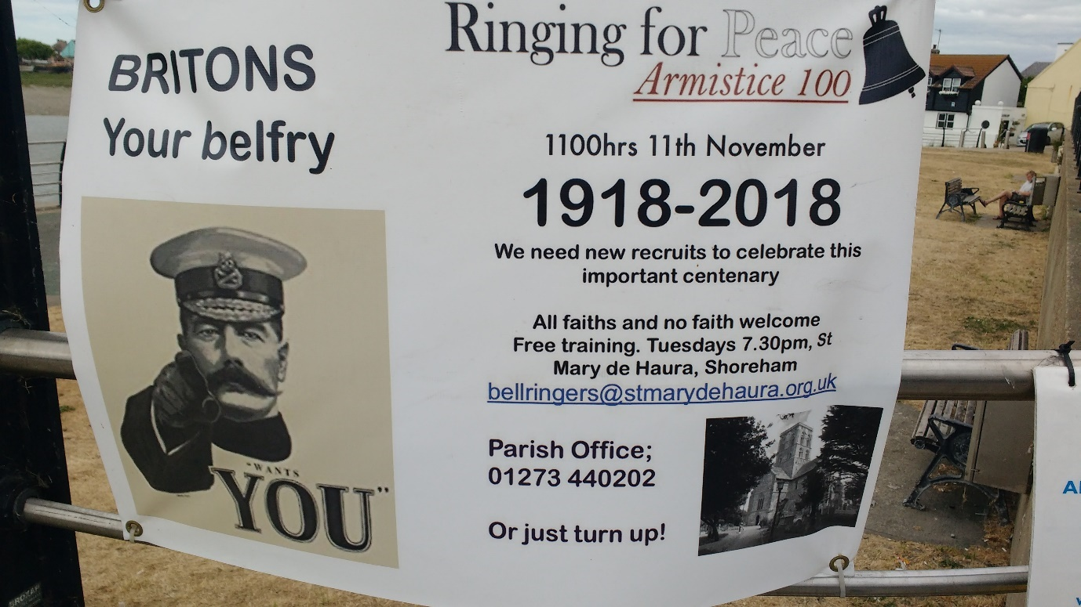
*******************
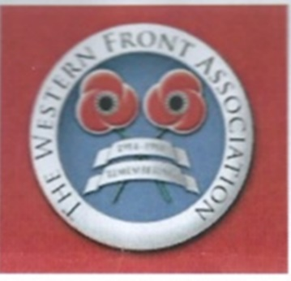
SUSSEX

Future Speakers

14th December – Luci Gosling – Major Richardson and the War Dog School Preceded by AGM

8th February 2019 – Geoffrey Vessey-Holt - "A Sussex Tank Corps Hero in Action in 1918 - the Long Hard Road to Victory"

12th April – Rob Thompson – Logistics based -Subject TBC More information to come

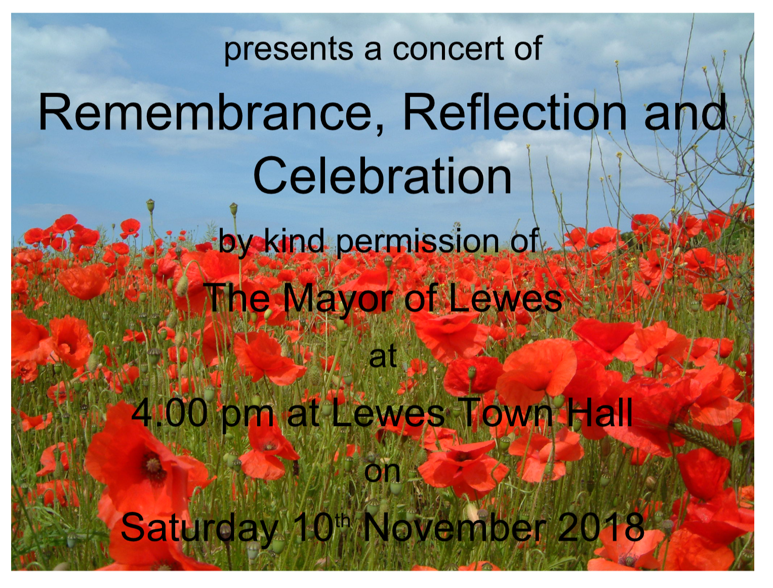

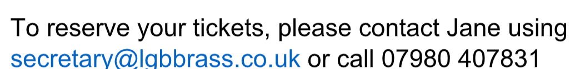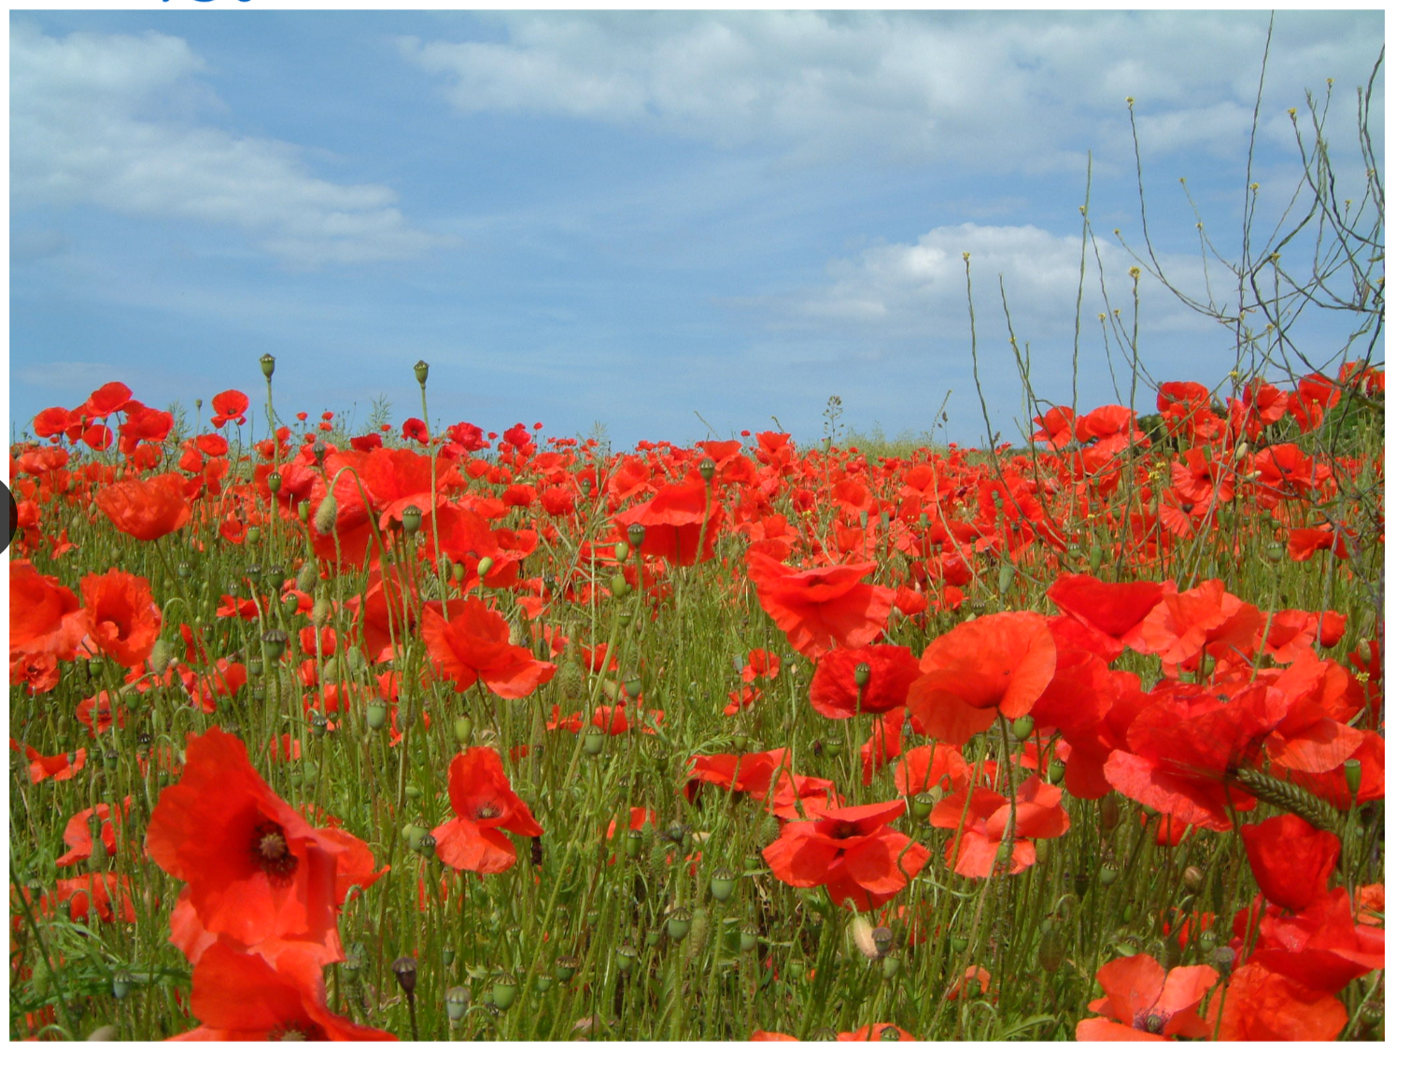

Thanks to Geoff Bridger

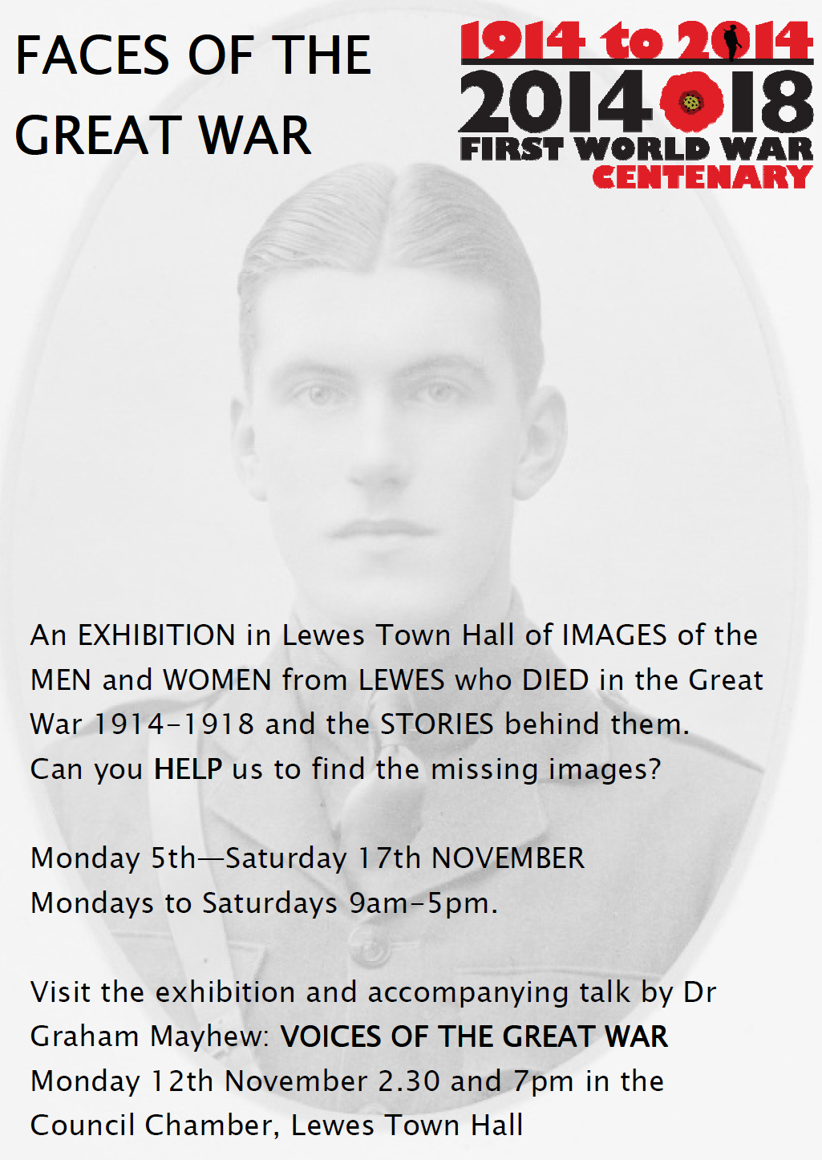

Thanks to Geoff Bridger

