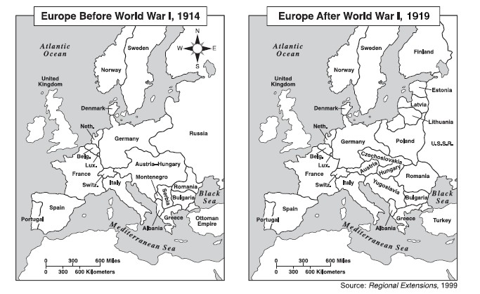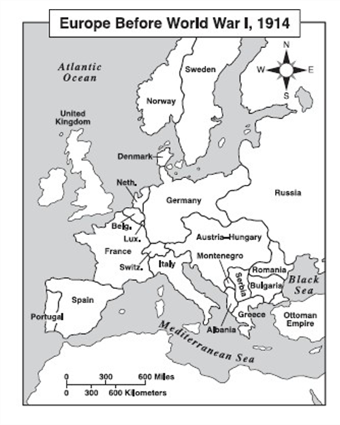

You will need 2 colours.

* Colour in Germany and her allies in one colour.
* Colour in Britain and her allies in another colour.

Use the information sheet to help you work out who supported who in the war.

You will need 2 colours.

* Colour in Germany and her allies in one colour.
* Colour in Britain and her allies in another colour.

Use the information sheet to help you work out who supported who in the war.