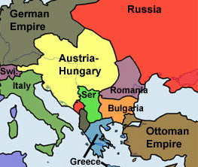
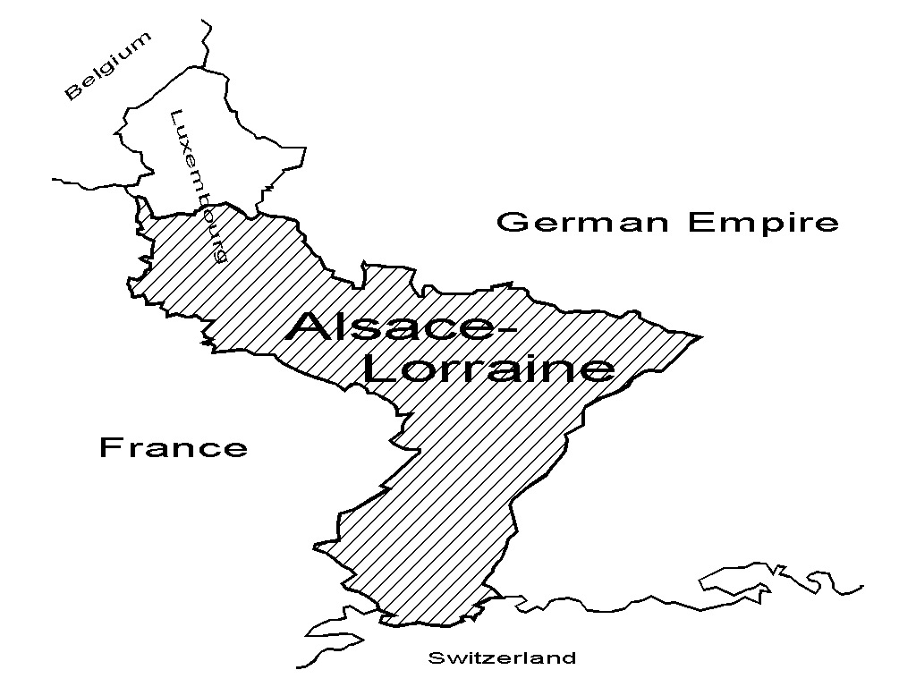
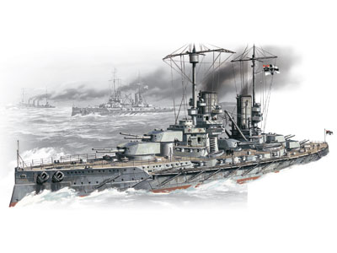
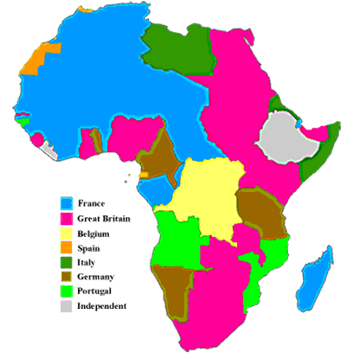

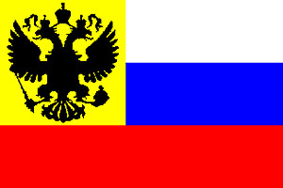
Navy
Britain was worried by Germany's desire to increase the size of her navy. Britain accepted that Germany needed a large army. But Germany had a very small coastline and Britain could not accept that Germany needed a large navy.

Colonies
Germany believed that a sign of a great power was to have an empire through possession of overseas colonies. The 'best' had already been taken by Britain but Germany wanted to gain as much colonial territory as possible.
French Fear
France had a huge army but a poor navy and so was suspicious of Germany and her power. So France allied with Britain in 1904 (called the ‘Entente Cordiale’), who had a large navy.
Franco-Prussian War
France went to war in 1870 and was badly beaten. It lost two provinces as a result, Alsace and Lorraine, damaging national pride. Ever since it has hated Germany.
Austrian Ambitions
Austria had been weak for many years, but wanted to expand her empire. Serbia, was in the way and was a long time ally of Russia. Austria knew it could not beat Russia without German help.

Russian Ambitions
Russia had been defeated by Japan in 1905 and wanted to prove that she was still a big power. They believed they could defeat any other European country.

