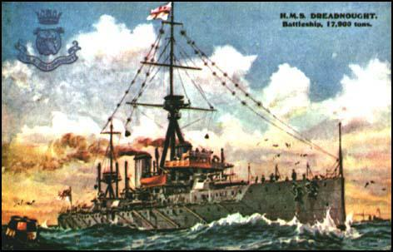
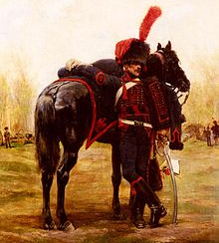
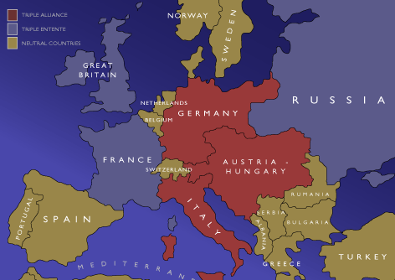
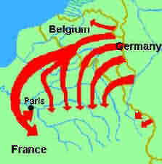
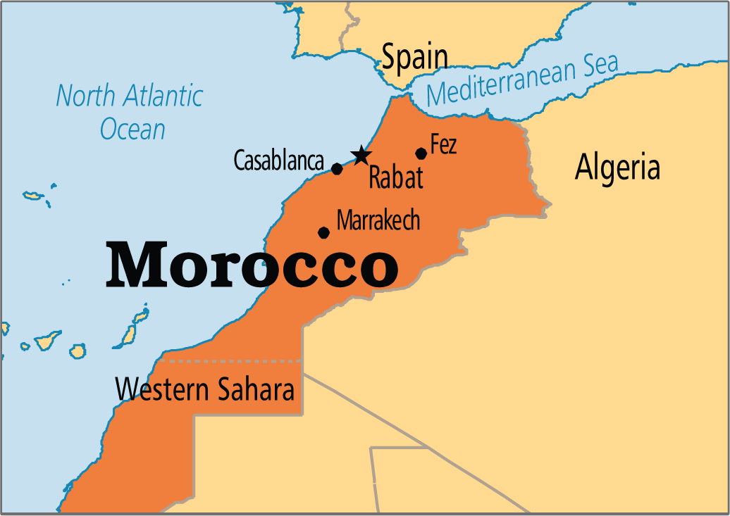
Dreadnaughts
Britain invented a new type of battleship in 1906, that was much more powerful than any other. As a result, there was a race to build as many as possible between Germany and Britain.
Arms Race
Spending on the military increased 300% in the main European Countries between 1870 and 1914. Most countries brought in ‘conscription’, meaning every man over 18 had to serve in the military for some time.
The Triple Entente
Britain, France and Russia were worried by ‘The Triple Alliance’ so formed an alliance called the Triple Entente (agreement) in 1907.
The Triple Alliance
Germany, Austria-Hungary and Italy formed an alliance in 1882 (agreement to fight together if there was a war) called the ‘Triple Alliance’.
The Schlieffen Plan
Count von Schlieffen was a German general who devised a way to fight against Russia and France, by defeating France quickly, in 1905. It involved marching through Belgium and meant that Germany had to prepare for war once it was inevitable.
Morocco
France wanted to expand her empire in Morocco between 1906 and 1911, which Germany opposed, hoping to drive a weedge between Britain and France. This had the opposite effect and France and Britain became closer allies.

