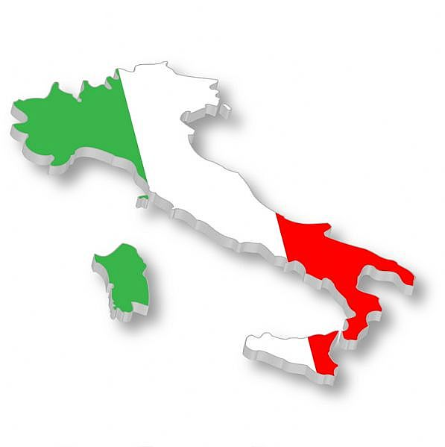


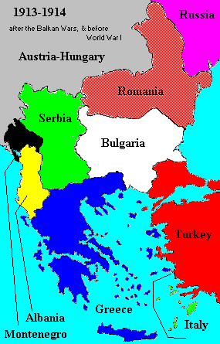
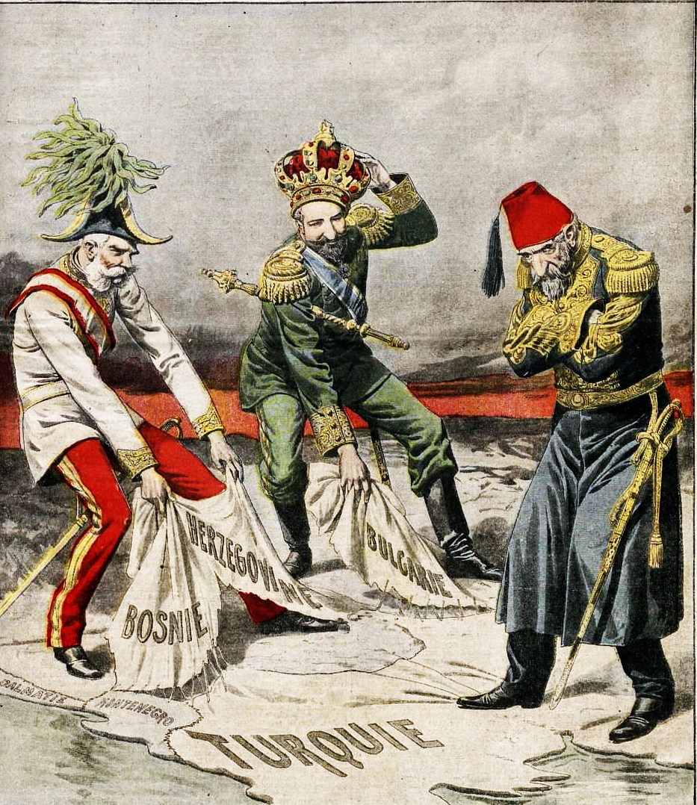
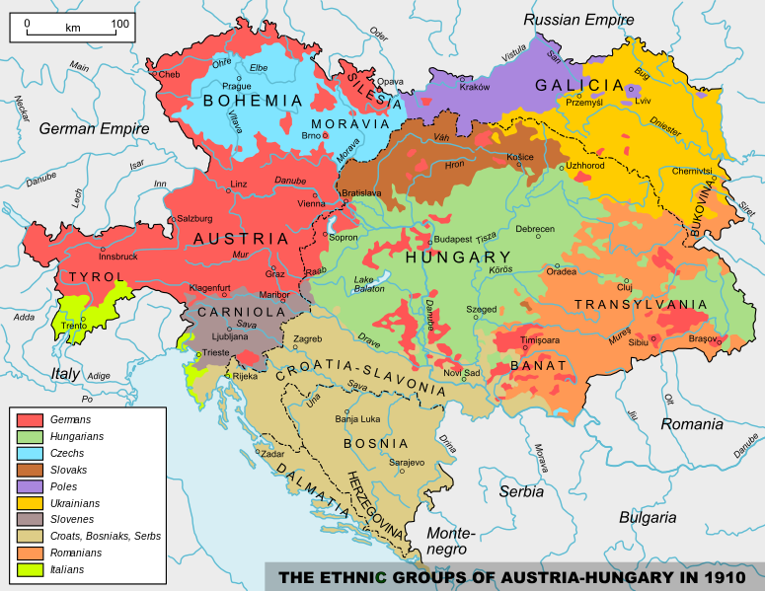
Unification of Italy
Italy was unified in 1861 for the first time in 1,300 years. They wanted to make up for lost time and declare their power to the rest of Europe.
Nationalism in the Austrian Empire
The Austrian Empire was made up of lots of different ethnic groups and nationalities, many of whom wanted freedom to have their own states. Many also hated one another.
Need for Markets
As more countries industrialised, they needed markets to sell their goods. One way of guaranteeing markets was with colonies.
Balkans Wars
In 1912-13, Serbia ‘helped’ many other countries in the Balkans free themselves from rule by the Ottomans (Turkish). Serbia grew a great deal in size.
British-Belgian Alliance
Britain and Belgium had an old alliance from 1839. The Germans thought that the British wouldn’t mind if they went through Belgium to get to France.
Bosnian Crisis
Austrian annexed (took over) Bosnia in 1908. This angered Russia and Serbia, permanently damaging its relations with these two countries.

