The Causes of World War One
Fallout from the Assassination
The Great Powers had managed to stay out of the Balkan Wars in 1912/13. Could they keep out of this crisis in the Balkans as well, or would Austria-Hungary (A.H) use the assassination of her Archduke (and heir to the throne) as an opportunity for a final showdown with Serbia? For several weeks little happened as A.H was seeking the support of her ally, Germany, before moving against Serbia. On 23rd July 1914, with German support guaranteed, A.H issued Serbia with TEN demands – an ultimatum. Serbia was given FORTY-EIGHT hours to agree. Serbia accepted all but ONE demand, they did not accept that Austrian judges be allowed into Serbia to investigate the assassination. This was not enough for A.H and war was declared, exactly as A.H had hoped and on 28th July A.H declared war on Serbia.
Russia was now prepared to go to war to help Serbia. Germany supported A.H declaring war on Serbia and tried to persuade Russia to halt her mobilisation. However stopping an army of millions when it has begun is not easy and Germany and Russia did not trust each other. Therefore, on 1st August Germany declared war on Russia and on 3rd August Germany declared war on France.
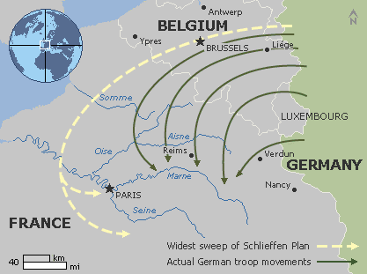
The Schlieffen Plan (launched 2nd August 1914)
The Entente Cordial, signed in 1904 between Britain and France with plans to add Russia, aimed to combat the threat of Germany. The German military became concerned as Germany lies between France and Russia. German Army Chief of Staff, Alfred von Schlieffen came up with a plan that was intended to enable Germany to launch a joint attack upon France and Russia in the event of war. His plan relied upon France being quickly defeated first so that the German army could move quickly to the east and fight Russia before the Russian army could mobilise. The French-German border was heavily defended so the German army would have to invade through neutral Belgium. Belgian neutrality had been guaranteed by both Britain and Germany in the Treaty of London 1839 so when the Schlieffen Plan was launched Britain declared war on Germany to protect Belgium.
The attack on France did not go as smoothly as von Schlieffen had hoped. The Russian army mobilised far quicker than the Germans had anticipated, the Belgian army was resisting the German advance, and the British Expeditionary Force reached France and Belgium much quicker than expected.5
- What was the aim of the Schlieffen Plan?
- What problems did Germany face that caused the Schlieffen Plan to fail?
- Using a map sheet, plot on the path of the Schlieffen Plan.

