United States of America

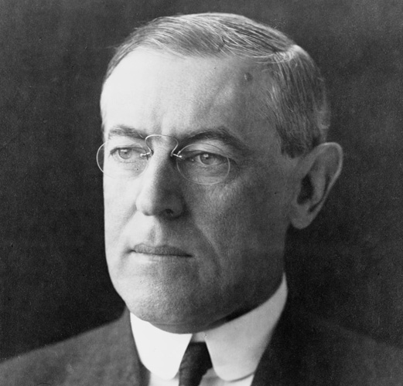

Joined the war in 1917 – had not lost as many man as Britain or France and had not spent as much money.

USA was in favour of a lenient peace settlement to be imposed on Germany.
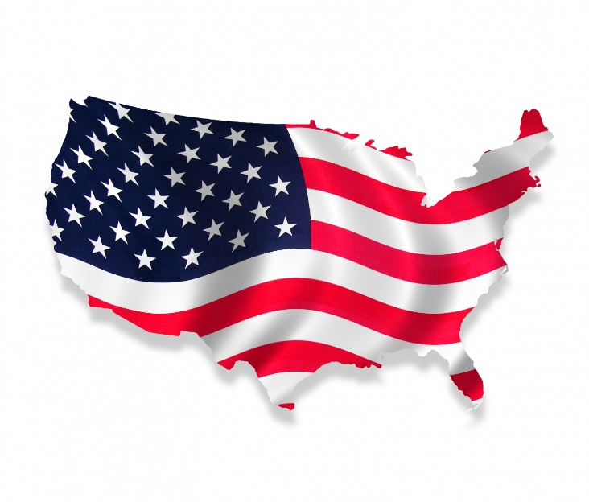

Britain and the Empire

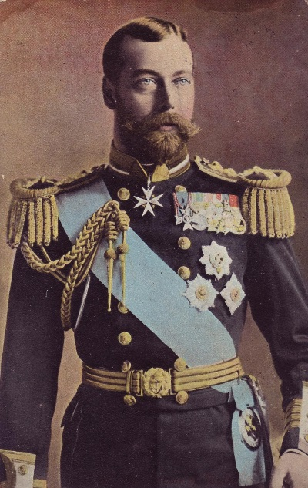
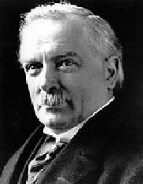
Prime Minister David Lloyd George King George V

GB. Lloyd George was in favour of a less severe settlement to that of the French. He wanted to ensure Germany could recover quickly and resume her role as a major customer of British goods.

France

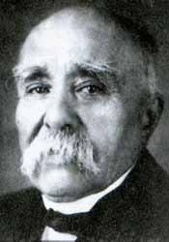
Prime Minister – George Clemenceau

France wanted a harsh peace settlement to ruin Germany economically and militarily
France wanted to Germany to pay Reparations (compensation)
Clemenceau’s nick name was ‘Tiger’ for his aggressive attitude towards Germany.

