Technology during World War One

Technology Pre 1914
Russian artillery at Sebastopol 1855

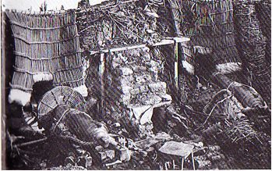

Rifles from the American Civil War 1863
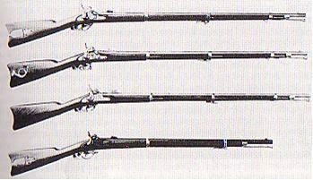

The use of Steam locomotives during the American civil war 1864.
Why was railway development a significant development in warfare?

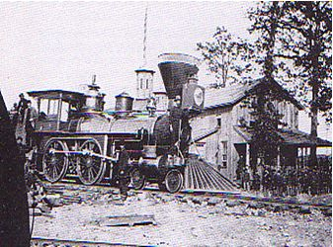

The ‘New’ Technology of World War One

The German 150mm Howitzer

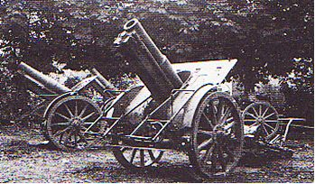

A German ‘Bertha’ 305mm Howitzer

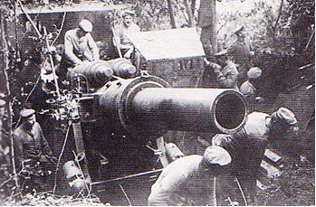

‘Slim Emmas’ –Austrian artillery howitzer

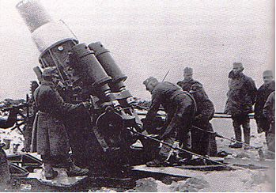

British troops at the Somme 1916

What two weapons of trench warfare are shown?
What features of the photograph suggest this was a staged photograph?

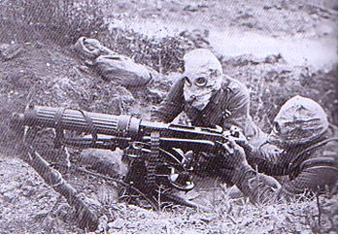
The New weapons of World War One
A British Mark I tank 1916.
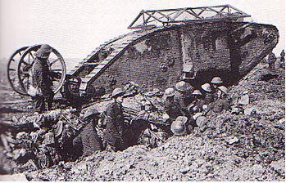

German Tank 1918

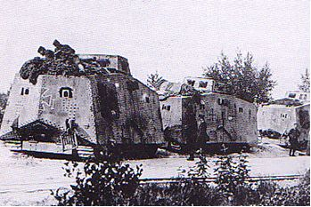

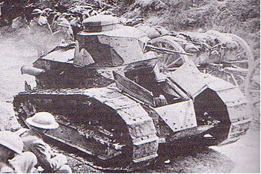

French Light Renault Tank 1918

British Machine Gun Battalion

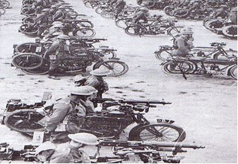

A German flame thrower being used by German ‘storm troops’

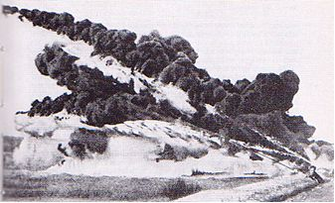

The War in the Air and at Sea

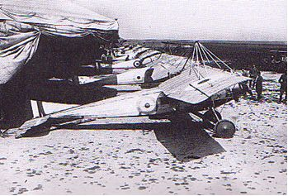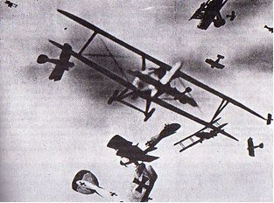

RFC planes 1917 A dogfight over France 1917

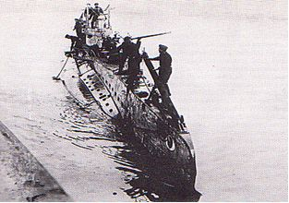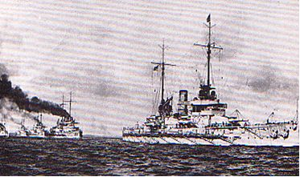

A German U Boat 1916 A fleet of German Dreadnoughts

