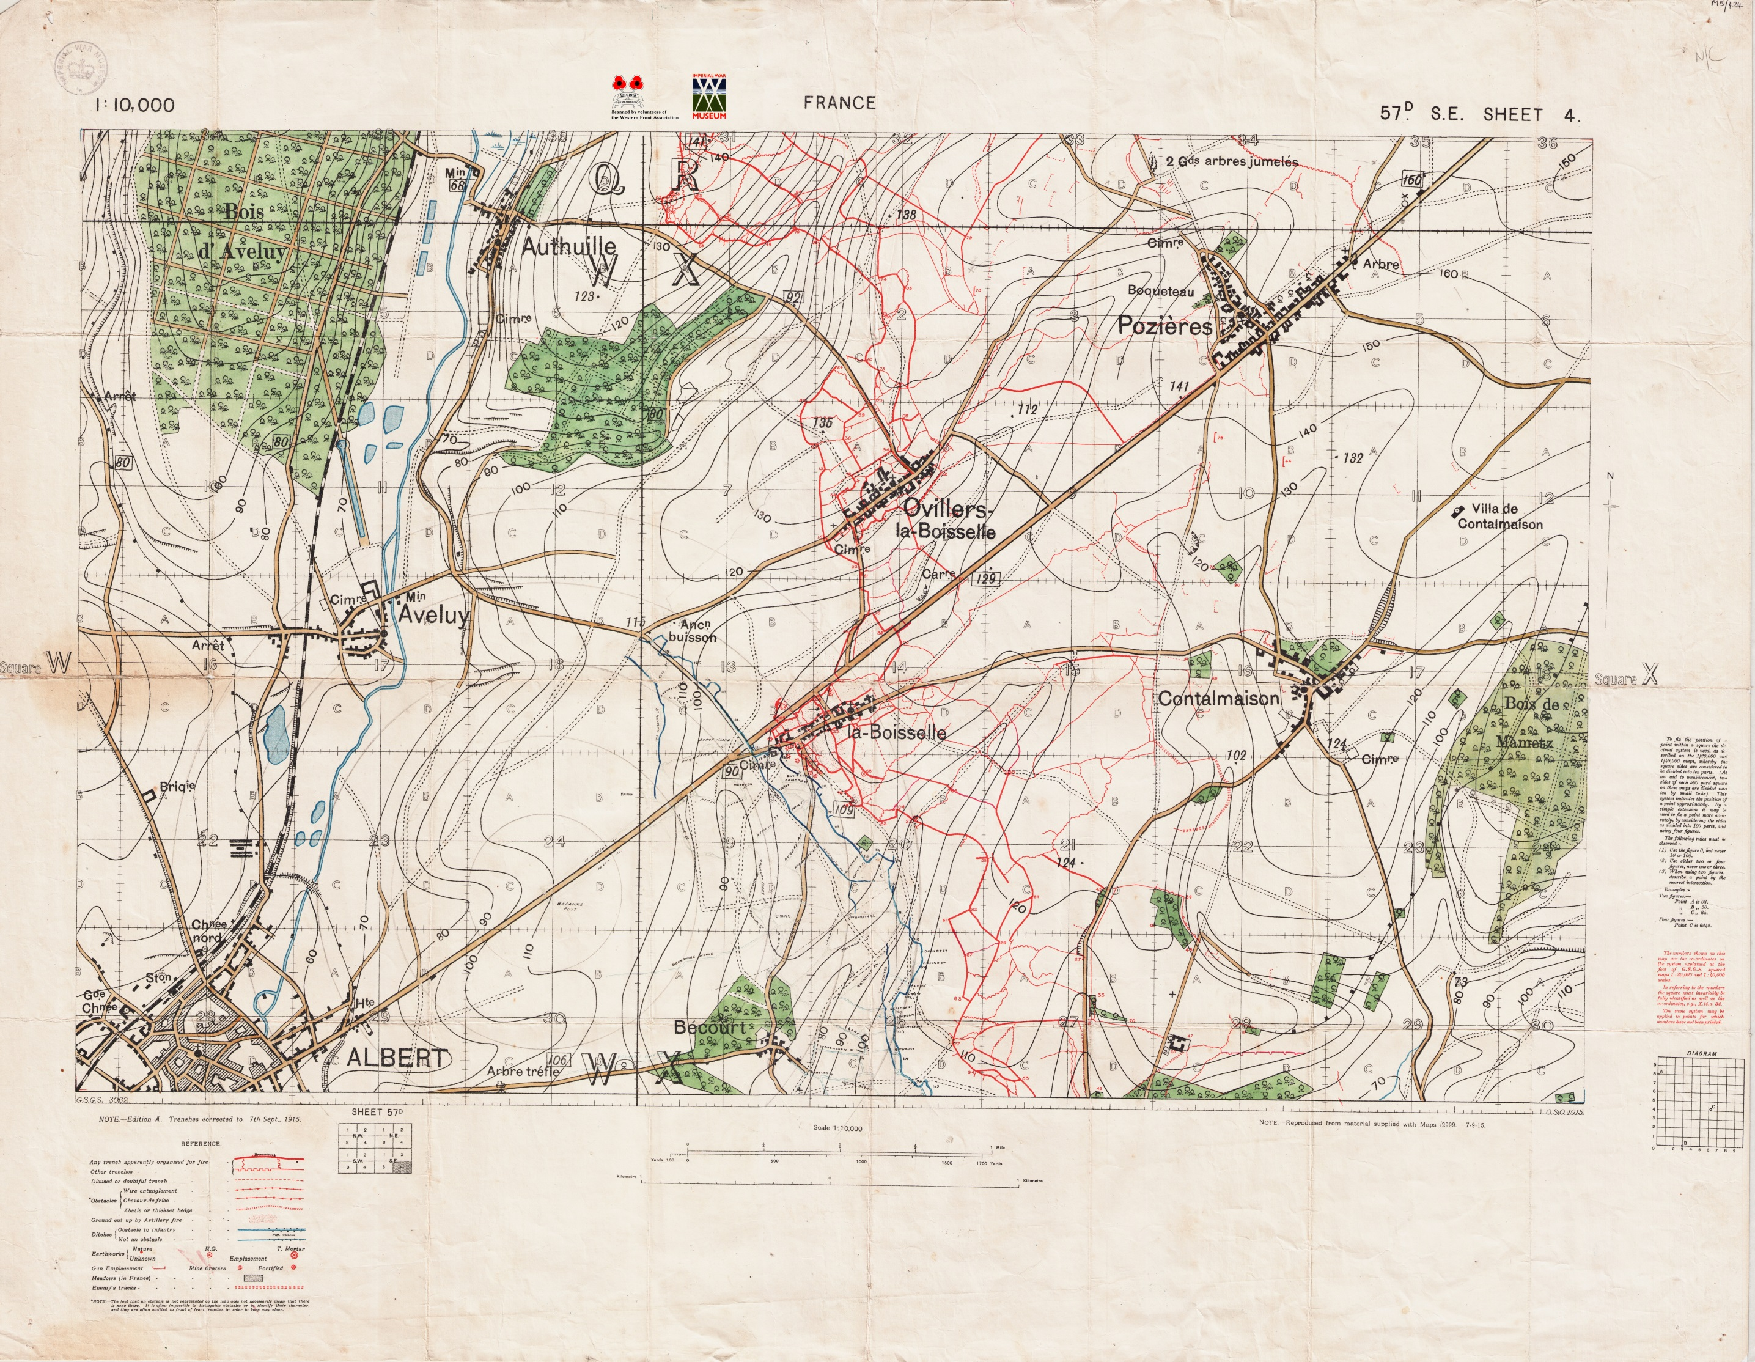

Command- General______________________

Deputy General________________

Battle Date ___/___/1__

Key – insert the symbol you are given.

British Positions German Positions Strong Defence

Barbed Wire Artillery Guns Mine

Guns Target position