Worksheet: WWI – The Somme: Keeping it real

What part was played by Britain in the defeat of Germany in the First World War?

Step 1: Look at the photograph (below) of the AA Road Scouts enlisting to join the army in September 1914. It is highly likely that these young men would have formed a ‘pals’ battalion and sent to fight on the Western Front

Step 2: The enlistees are in standing in 3 rows. Use a red pen to draw a circle around each of the faces you can make out in these lines (there are roughly 60 men)

Did you know that on the first day of the battle of the Somme on the Western Front:

- There were 57,000 British casualties
- 1 in 4 men were wounded
- 1 in 10 men were killed

Step 3: Go back to the photograph and put an X through all the men that would have died and a / through all those wounded. Look again at the photograph – try to imagine if it had been you friends/classmates

Step 4: Using the notes (below) write a short paragraph to answer the question:

How important do you think the comradeship of the ‘Pals’ battalions was in maintaining morale on the Western Front and what part did they play in the defeat of Germany?

This activity relates to the WWI: Joining up Teaching Activity
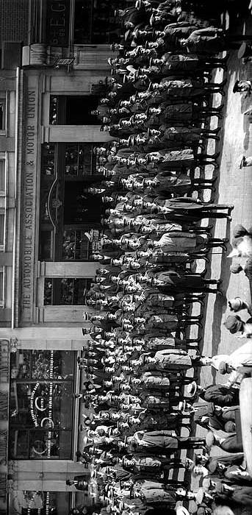
AA Road Scouts enlisting for the First World War – September 1914

Notes: WWI – Joining up and the Somme

- When Britain declared war on Germany on the 4th August 1914 it had a regular army of just 450,000 men

- On the 6th of August, the Secretary of War, Lord Kitchener asked for 100,000 new recruits. Whole streets, villages and companies of patriotic men queued to enlist in the British Army. These became known as the ‘Pals’ battalions

- By the end of 1915 around 2.5 million men had volunteered for military service

- As the war continued casualties grew and by January 1916 conscription (forced enrolment in the armed service) was introduced for all single men aged 18 – 41

- On the first day of the Battle of the Somme (1st July 1916) alone there were 57,000 British casualties. In real terms 1 in 4 men were wounded and 1 in 10 killed. For many soldiers this was their first (and last) day of battle

- Casualties varied amongst battalions, but many ‘Pals’ battalions suffered heavy losses. For example of 720 men in the Accrington Pals, 584 (8 out of every 10) men were wounded, killed or missing. The Leeds Pals suffered similarly high losses with 750 out of 900 men suffering the same fate

- These high losses had a devastating effect on morale ‘back home’. In towns such Accrington, Leeds and many others almost every family had lost loved ones. The euphoria of enlistment in 1914 gave way to a wave of grief

- The British Empire (British Isles, British West Indies, Canada, British Guiana; British West Africa, British East Africa, India, Australia, New Zealand) mobilized 8,780,000 men during WWI. Of these 900,000 (10%) died and 2,090,000 (24%) were wounded

- The sustained mental and physical stresses of trench warfare in WW1 also created a new kind of injury – shellshock. This was a psychological illness, often resulting in nervous breakdown. Many men were unable to return to military duties, but there was little sympathy for their suffering. It could also occur when men returned home after the war, as many found it difficult to re-adjust to normal life

