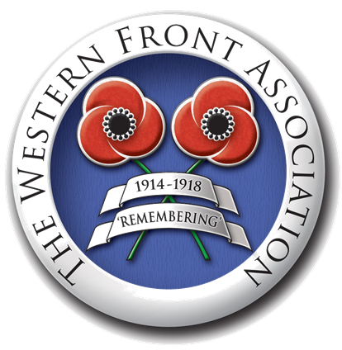
The Impact of the War on the German citizens
Economic

- Rationing/ shortages and the role of Blockade,
- ‘War economy’
- ‘Turnip Winter’,
- Civilian casualties.

Political
- Pen portrait of Germany in 1914.
- Structure and role in the Government of the Kaiser.
- Role of Hindenburg and Ludendorff and the move towards dictatorship.
- I918 Revolution and the establishment of the Weimar Republic.
- Effects of defeat and reactions to Versailles.
- Opponents to the War.

Cultural

Impact of defeat.

Recruitment etc.

Stab in the Back theory’.

Social

- War aims
- Propaganda,
- Effects on civilians

What effect did World War One have on the civilian population of Germany?

