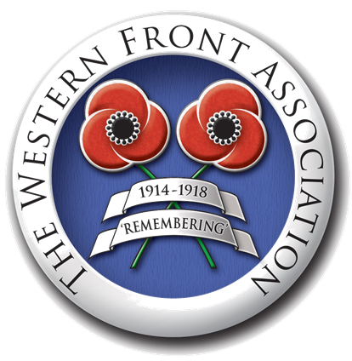
What was the Legacy of Versailles?

German discontent

A Redrawn Map

The League of Nations

Break up of the allies

Future disputes

Sympathy for Germany

Enforcement issues

