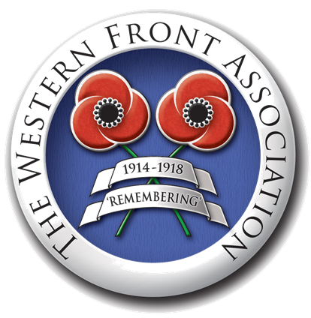
The Treaty of Versailles- why was Peace necessary?
New Nations

War Costs
Redrawing the Map of Europe

Why was peace necessary?

Damage done
The Balance of Power

Collapse of European Empires
The Defeated Nations
Future Peace

Who were the peacemakers?

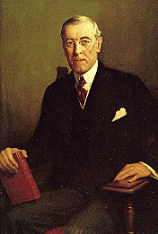

Woodrow Wilson
Aims and objectives:

Motives/dilemmas:

Georges Clemenceau
Aims and objectives:

Motives/dilemmas:
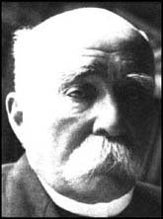

David Lloyd George
Aims and objectives:

Motives/dilemmas:
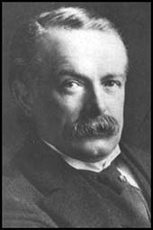

Demilitarisation
Territorial Losses
What were the Terms of the Treaty?

Reparations
War Guilt Clause

Explain how the Treaty affected Germany Politically and culturally:

Explain how the Treaty affected Germany militarily:

Explain how the Treaty affected Germany Economically:

