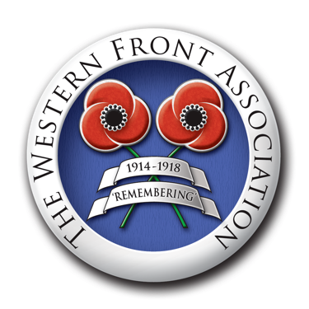

**Autumn Project with Prizes for 12-14 year olds**

**Front Page News!**

Newspapers were very important during the First World War. Because there was no television, online news or social media, newspapers were the way most people found out what was happening in the conflict.

For this year’s Project with Prizes, we would like you to create the front page of a daily newspaper featuring an event that happened during the First World War.

You can choose anything that occured between 4 August 1914, when Britain declared war on Germany, to 11 November 1920, when the first Armistice Day was held to commemorate those who had died in the Great War. Then we would like you to:

Write a front page news item about it.

Or

Design a front page including a headline and a picture

Or

A combination of headline, words and pictures

Your front page can be for a national or local newspaper. Newspapers have changed in the last hundred years but you may base your work on newspapers as they are today rather than as they actually were during the war. There would have been censorship during the war - some things were not reported for security reasons - but for this project, you can include anything you think is relevant.

You can choose an important national event such as:

War is declared 1914

Recruiting for Kitchener’s Army 1914

The first day of the Battle of the Somme 1916

The first tanks used in battle 1916

The introduction of food rationing in 1918

The end of the war 11 November 1918

Bringing the Unknown Warrior to Westminster Abbey 1920

Or you may be able to find out about something that happened in your town, like one of these:

The destruction of a zeppelin (Cuffley, 1916)

The bombing of Upper North Street School (Poplar, 1917)

The factory opened for Belgian refugees in Barnes

Or you could find out about someone on your local war memorial and make their death front page news.

Or any other First World War related, newsworthy event that you find interesting.

Make sure your headline captures the story in a few words and catches attention!

If you are writing an article, remember that it must answer these questions briefly in the first paragraph:

Who?

What?

When?

Where?

How?

The rest of the article should answer these questions in more detail and may include interviews and suggest how this story may continue in the next few days or weeks.

**Make sure you have included your name, age and name of your school.**

**What Happens Next?**

**Entries should be submitted by teachers to** [**education@westernfrontassociation.com**](mailto:education@westernfrontassociation.com)**.**

Closing date - 22 November 2024

The creators of the best entries will receive a book and certificate, runners up will receive certificates.

Winners’ schools will be invited to enter a ballot for an invitation to the Western Front Association Service of Remembrance on 11 November 2025.

Good luck!